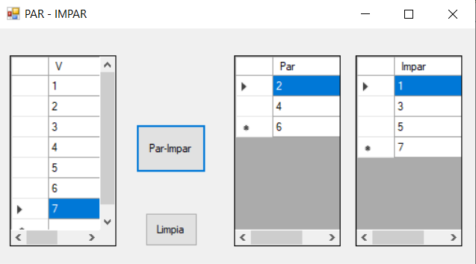

namespace VectoresParesImpares

{

public partial class Form1 : Form

{

public Form1()

{

InitializeComponent();

}

private void button1_Click(object sender, EventArgs e)

{

int fV, fP, fI, par=0,impar=0,i;

fV = dg1.RowCount - 1;

int[] V = new int[fV];

int[] P = new int[fV];

int[] I = new int[fV];

for(i=0;i<fV;i++)

{

V[i] = Convert.ToInt32(dg1[0, i].Value);

}

for(i=0;i<fV;i++)

{

if(V[i]%2 ==0)

{

P[par]=V[i];

par++;

}

else

{

I[impar]=V[i];

impar++;

}

}

if (par == 0) dgpar.RowCount = 1;

else

dgpar.RowCount = par;

if (impar == 0) dgimpar.RowCount = 1;

else

dgimpar.RowCount = impar;

for (i = 0; i < par; i++)

dgpar[0, i].Value = P[i].ToString();

for (i = 0; i < impar; i++)

dgimpar[0, i].Value = I[i].ToString();

}

private void button2_Click(object sender, EventArgs e)

{

dg1.Rows.Clear();

dgimpar.Rows.Clear();

dgpar.Rows.Clear();

}

}

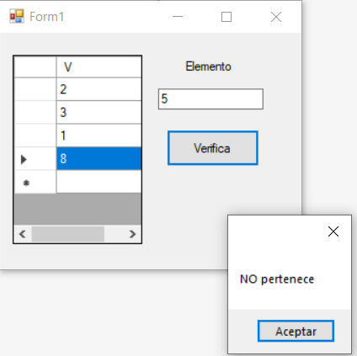

namespace VecroresMiembro

{

public partial class Form1 : Form

{

public Form1()

{

InitializeComponent();

}

private void button1_Click(object sender, EventArgs e)

{

int[] V;

int elem,filas,i;

filas = dg.RowCount-1;

V = new int[filas];

elem = Convert.ToInt32(textBox1.Text);

for(i=0;i<filas;i++)

{

V[i] = Convert.ToInt32(dg[0, i].Value);

}

for (i = 0; i < filas; i++)

if (V[i] == elem)

break;

if (i < filas)

MessageBox.Show("Pertenece");

else

MessageBox.Show("NO pertenece");

}

}

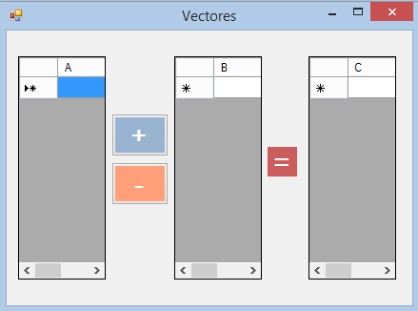

namespace VectoresSumaResta

{

public partial class Form1 : Form

{

int fA, fB;

double []A;

double []B;

double []C;

public Form1()

{

InitializeComponent();

}

private void suma_Click(object sender, EventArgs e)

{

fA = lee_filas(dgA);

fB = lee_filas(dgB);

if (fA != fB)

MessageBox.Show("La dimensión de los vectores no es igual");

else

{

dgC.Rows.Clear();

lee_vectores();

for (int i = 0; i < fA; i++)

{

C[i] = A[i] + B[i];

}

imprime_vector(C, fA, dgC);

}

}

private int lee_filas(DataGridView DG)

{

int filas;

filas = DG.RowCount-1;

return(filas);

}

private double [] lee_dataGrid(DataGridView DG)

{

int filas;

filas = DG.RowCount-1;

double [] V = new double[filas];

for(int i=0;i<filas;i++)

{

V[i] = Convert.ToDouble(DG[0,i].Value);

}

return (V);

}

private void lee_vectores()

{

A = new double[fA];

A = lee_dataGrid(dgA);

B = new double[fB];

B = lee_dataGrid(dgB);

C = new double[fA];

}

private void imprime_vector(double [] V, int F, DataGridView DG)

{

DG.RowCount = F;

for (int i = 0; i < F; i++)

{

DG[0, i].Value = V[i].ToString();

}

}

private void resta_Click(object sender, EventArgs e)

{

fA = lee_filas(dgA);

fB = lee_filas(dgB);

if (fA != fB)

MessageBox.Show("La dimensión de los vectores no es igual");

else

{

dgC.Rows.Clear();

lee_vectores();

for (int i = 0; i < fA; i++)

{

C[i] = A[i] - B[i];

}

imprime_vector(C, fA, dgC);

}

}

}

}